MYSTERY CITY ADVENTURES
Product strategy & phased delivery plan | Working concept | October 2026
A playful real-world discovery app that transforms nearby places into personalized, story-driven adventures, with an animated companion and a scrolling quest path.

Executive summary
The product combines the emotional appeal of surprise outings with the usability of a flexible itinerary planner. Users choose a theme or mix interests, set practical constraints, and follow a Candy Crush-inspired vertical chapter path. A Finch-inspired mascot reacts to clues, discoveries, breaks, and completed stops. The route engine quietly optimizes real venues for proximity, hours, cost and suitability; the map is not the primary interface.

North-star experience
- Select a curated package or mix up to three themes; choose group, duration, budget, mobility and transport preferences.
- Preview a spoiler-safe itinerary, including activity types and logistics, then customize it.
- Progress through a long, scrollable illustrated path: completed stops checked, current stop highlighted, future chapters locked.
- Reveal the next real location, navigate externally, optionally engage with a clue or micro-quest, and mark the chapter complete.
- Earn stamps and a meaningful recap without penalizing skipped puzzles or early reveals.

Concept art — existing exploratory mockups
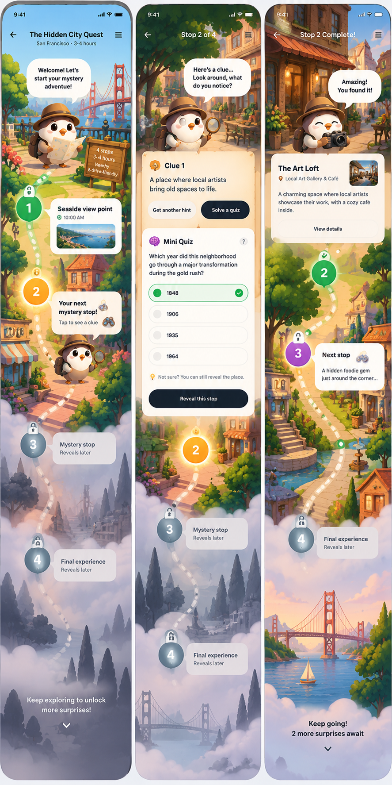
Concept A — scrolling mystery path and progressive location reveals; illustrative UI, not final design.

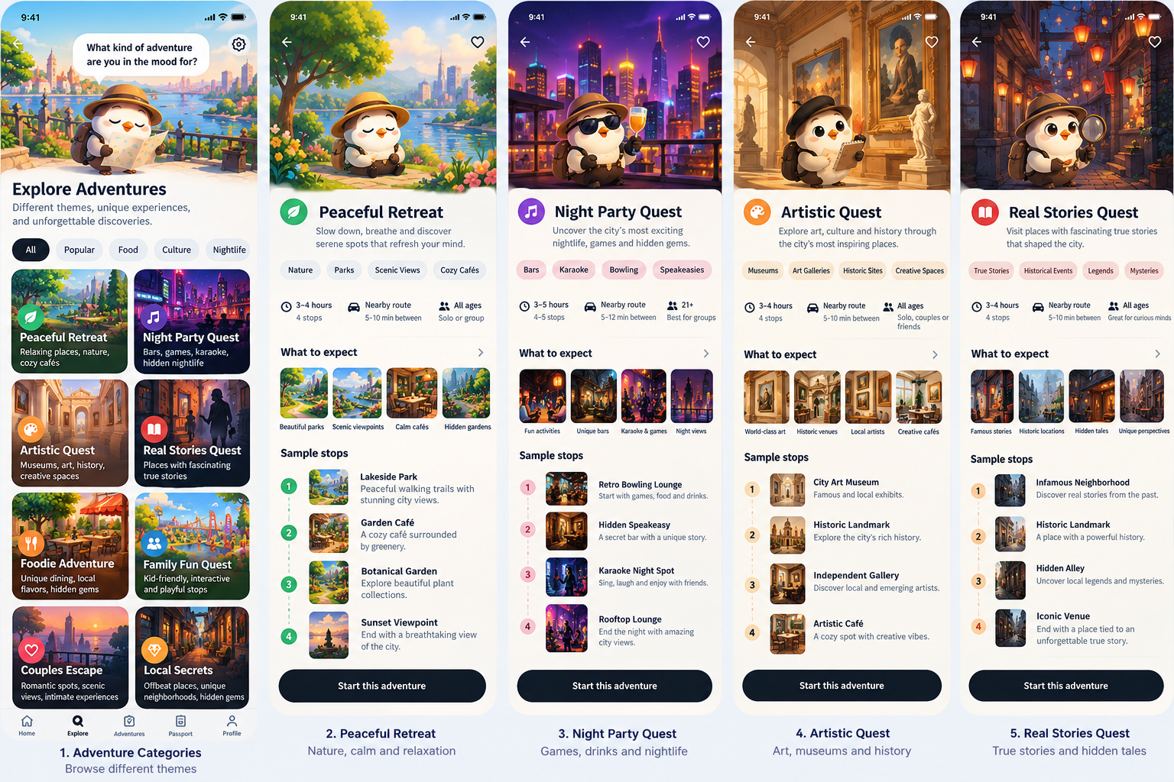
Concept B — themed package discovery and sample adventure detail screens.

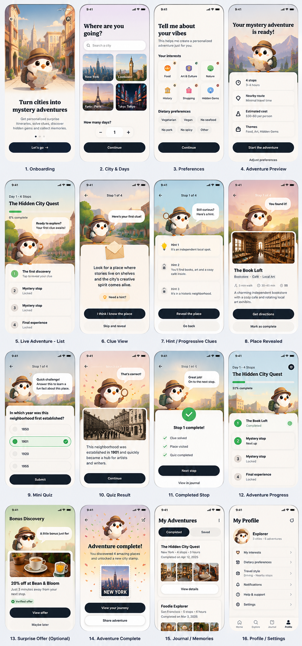
Concept C — broad UI exploration across onboarding, quests, progress and memories.

1. Audience and value proposition
Audience / occasion | Primary job to be done | Experience fit
Couples / dates | Find a memorable outing without planning fatigue | Romance + art + food; balanced mystery
Friends / birthdays | Create a shared, playful occasion | Games + nightlife + hidden gems
Families | Explore safely at an age-appropriate pace | Nature + science + simple observation quests
Solo locals / tourists | Break routine or discover a new neighborhood | Hidden gems + culture + cafés
Mixed ages / mobility needs | Enjoy a manageable outing without excessive travel | Gentle pace, seating, accessibility filters

2. Adventure catalog and package engine
Launch with a small set of signature packages, while designing the underlying system to support a larger catalog. Categories are thematic ingredients, not 24 separately hardcoded route engines.
Family themes | Examples
Calm & outdoors | Peaceful Escapes; Nature; Botanical; Wellness; Stargazing
Culture & stories | Art & Time Travel; True Stories; Architecture; Books; Cinema; Science
Social & occasions | Romance; After Dark; Play & Competition; Family Wonderlands
Food & local life | Flavor Trails; Local Life; Hidden City Mysteries
Creative & visual | Photography; Crafts; Nostalgia; Style & Treasure Hunting
Special constraints | Pet Friendly; Easygoing Explorer (also available as filters)

Featured hybrid packages
- Love, Art & Little Secrets — Romance + Art + Food
- Neon Nights & Secret Doors — Nightlife + Games + Hidden Gems
- Breathe, Bloom & Sip — Peaceful + Botanical + Food
- Whispers of the Past — True Stories + History + Literature
- Little Detectives, Big Discoveries — Family + Science + Mystery
- Taste the Neighborhood — Food + Street Art + Local Life
- Rewind the City — Nostalgia + Cinema + Food
- Chasing Golden Hour — Photography + Nature + Romance
Package generation rules: select a dominant emotional arc; blend up to two secondary themes; confirm sufficient suitable nearby venues; construct 3–5 chapters with variety; validate opening hours, access and costs; attach optional, fact-checked quests; present a final reveal. Decline or modify incoherent combinations rather than forcing them.

3. Mystery modes
Mode | Reveal behavior | Editing
Full Mystery | Future venues hidden; logistical constraints visible | Swap by category without spoilers; reveal anytime
Balanced Mystery — default | Activity types shown; exact venue unlocked chapter by chapter | Swap categories or choose named alternatives
Open Explorer | All stops and venues visible upfront | Reorder, replace and remove, subject to route validation
Mystery is a presentation choice, not a restriction on user autonomy. Users can switch modes, reveal any venue, pause, skip, or end without losing earned progress.

4. Balanced Mystery: core interaction rules
- Preview: show chapter category, time, estimated price, accessibility, booking requirements, and approximate travel burden; hide exact address and identifying imagery.
- Unlock: show exact name, address, hours, admission and navigation when chapter becomes active, or on early reveal. Never re-lock information already revealed.
- Swap: offer “Surprise me again” (same category, venue hidden) or “Let me choose” (named validated alternatives).
- Editing: completed chapters are immutable history; future chapters can be swapped, removed or reordered if feasible. A current stop can be replaced with confirmation.
- Route transaction: calculate new route, time and price impact before applying; a failed reroute leaves the existing plan untouched.
- Quest rules: optional observation games, facts, riddles, conversation cards and mini-quizzes; never block navigation or progress.
- Progress: locked → revealed → completed, with skipped and replaced states; user confirmation supported without mandatory GPS.
- Recovery: closures, lateness, rain, poor connectivity or permission denial trigger graceful alternatives and clear messaging.

5. Screens and navigation
Screen / page | Primary content | MVP?
Home | Featured adventures, resume adventure, current city | Yes
Explore / Packages | Signature collections, theme filters and package details | Yes
Adventure setup | Group, budget, duration, pace, mobility, transport, mystery mode | Yes
Spoiler-safe preview | Chapter types, costs, time, route summary, edit actions | Yes
Adventure Path | Long scrolling Candy Crush-like chapter trail, mascot and progress | Yes — centerpiece
Chapter detail / reveal | Clue, real venue, fact, external navigation, complete / skip | Yes
Swap / edit sheet | Activity type changes, validated alternatives, route impact | Yes
Quest interaction | Optional trivia, observations and conversation prompts | Yes — lightweight
Completion / Passport | Stamps, recap, visited stops, history | Yes — simple
Profile / preferences | Accessibility, diet, privacy, motion/sound preferences | Yes — simple
Custom Adventure Mixer | Multi-theme user-driven blending | Later
Merchant offers / rewards | Verified promotions, redemption terms | Later
Group live session | Synchronized multiplayer progress and voting | Later
AI travel chat | Open-ended concierge and dynamic negotiation | Later

6. Core functional features
- Curated and verified venue dataset with category, coordinates, duration, cost, accessibility, hours, reservation requirements and source freshness.
- Geographically compact route generation, travel-time estimates, backtracking minimization and budget constraints.
- Theme-appropriate story arcs, factual local background and optional mini-quests.
- Mascot states: idle, curious, walking, celebrating, resting; background changes by theme/chapter.
- Persistence of itinerary versions, revealed information, progress, edits and completed chapters.
- External Apple Maps / Google Maps handoff; map not necessary on primary screen.
- User controls for reveal, swap, skip, pause, resume, end early and reduced motion.
- Safety and transparency: do not invent business offers or local facts; surface restrictions before commitment.

7. MVP: what to ship first
Recommended pilot: one city, three signature packages, 3–5 stops per adventure, walking-first compact neighborhoods. Target a polished end-to-end experience, not a large catalog.
MVP priority | Scope | Acceptance test
P0 | Onboarding / setup / package selection | User can configure a practical outing
P0 | Verified route + constraint checks | Route fits time, cost, venue hours and travel limits
P0 | Illustrated vertical adventure path | Current, completed and locked states remain legible
P0 | Balanced reveal + external navigation | Only active venue is exposed by default
P0 | Swap / skip / pause / persist | No loss of completed history or broken route state
P1 | Five mascot animation states | Companion responds at meaningful moments
P1 | Lightweight optional quests | At least one meaningful activity per package
P1 | Completion recap and passport stamp | User can revisit their experience

8. Post-MVP roadmap
Phase | Features | Gate to proceed
MVP / pilot | Three packages, Balanced mode, route engine, quest path, mascot, recap | Validated real-world completion and route reliability
MVP 1.1 | Full Mystery / Open Explorer modes; more swaps; offline saved details; more themes | Evidence that flexibility improves completion
MVP 2 | Adventure Mixer; personalized recommendations; weather-aware suggestions; more cities | Repeat usage and operationally scalable curation
MVP 3 | Group voting / sync; gifts; themed seasonal events; richer collections | Demonstrated group demand and paid conversion
Future platform | Verified merchant offers, booking links, creator tools, partnerships | Reliable merchant operations and sustainable unit economics

9. Product and technical architecture
Suggested iOS stack: SwiftUI for screens, a state-driven adventure session store, reusable character animations (Rive or Lottie if licensing/asset needs fit), a routing/maps provider for travel-time matrices, a backend for verified venues and route generation, and an LLM for constrained narrative/quest copy. AI should not be trusted to invent venues, hours, offers or facts.
Domain | Responsibilities
Venue service | Place IDs, hours, pricing, restrictions, accessibility, freshness
Route engine | Candidate selection, travel-time checks, ordering, budget/ETA validation
Adventure composer | Theme blend, chapter arc, stop-type balance, quest assignments
Narrative layer | Character dialogue, hints, concise fact-checked stories
Session state | Itinerary version, reveal state, completion events, pause / resume
Client UI | Illustrated scroll path, companion animation, chapter sheets, accessibility

10. Metrics, monetization and validation
Initial hypotheses to test: free/low-price teaser, approximately $6.99–$9.99 standard digital adventure, premium special-occasion and group packages. These are test prices, not validated demand. Venue admission, food and travel expenses must be separately disclosed.
Metric | Proposed pilot target (hypothesis)
Adventure completion | 80%+
Experience rating | 4.5 / 5
Meaningful new discovery | 70%+ of surveyed users
Major route / venue failures | Under 5%
Stated intent to buy again | 40%+
Actual repeat purchase | Observe over 60–90 days
Run a paid pilot with 30–50 groups. Measure checkout conversion, completion, route issues, user-reported enjoyment, support requests, and actual repeat purchase. Prioritize paid behavior over compliments.

11. Risks and mitigations
Risk | Mitigation
Bad venues or hallucinated details | Verified place data, freshness timestamps, source-backed stories
Route failures | Travel-time matrix, business-hour validation, fallback stops
Too much phone time | Short interactions; optional quests; no puzzle gate for directions
Scope creep | One city, three packages, single default mode for pilot
Low retention | Giftable occasions, seasonal routes, novelty and replay variety
High content / animation costs | Reusable mascot state machine, modular backgrounds and quest templates
Accessibility and safety | Hard filters, manual completion, early reveal, reduced-motion option

12. Immediate next steps
- Pick pilot city and 2–3 walkable neighborhoods; identify 40–60 viable venues.
- Write three complete example adventures, with 4 chapters each and verified logistics.
- Prototype the scrolling path and Balanced Mystery edit/reveal flows in SwiftUI.
- Define place and itinerary schemas, plus validation/rerouting service contracts.
- Create one mascot rig and five reusable animation states; prototype two scene backgrounds.
- Test with 10–15 groups, revise, then run a paid pilot with 30–50 groups.
Document note: All included illustrations are exploratory concept art. Place names, timings, UI labels and screens shown in mockups are not verified business data or final specifications.

